An array is the simplest data structure; it is a sequent collection of elements of similar data type and it stores a fixed number of data items in a consecutive memory location. Indexes are used to assess their data Items in array. The index range of an array of size N starts from 0 to N-1.

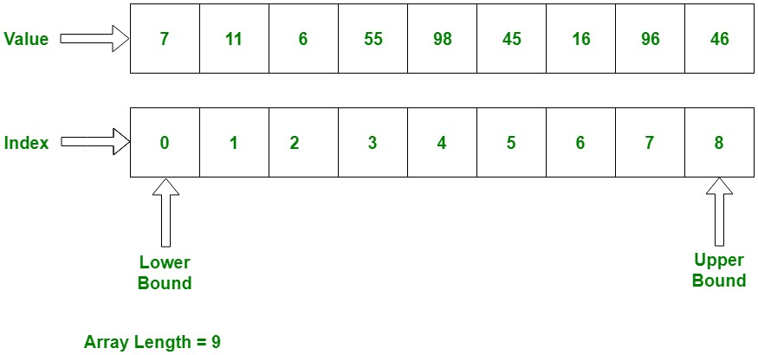

Types of Arrays

The Followings are the Types of Array

1- One dimensional array

2- Multi-dimensional array

1- One dimensional array

A one-dimensional array is a sequential collection of elements (often called array elements) that can be accessed specifically by specifying the position of the elements with their index values.

2- Multi-dimensional array

A multidimensional array has multiple indexes of each element in the array. The most generally used multidimensional array is the two-dimensional array or 2-D Array, it is also known as a table or matrix. A two-dimensional array has two indexes of Each element in the array. 2D array is identify by the notation (row, column)

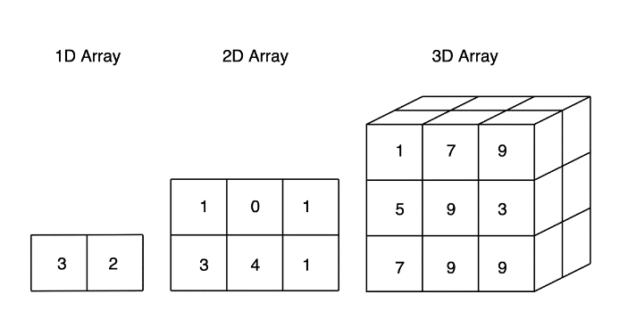

Basic Operations in Array

Traverse − it will show all the elements in array one by one

Insertion − it will add element in array of given Index

Deletion − Deletes an element at the given index.

Traverse OPERTAION IN ARRAY;

Traversal is completed by starting with the primary element of the array and getting to the last. Traversal operation are often utilized in counting the array elements, printing the values stored in an array, updating the prevailing values or summation all the element values. If a user wants to try to do similar calculation on each element of the array she is going to use traversal operation.

*Implementation of traversal operation.*

**import** array **as** arr

y=arr.array(**"i"**,([1,2,36,5,8,56)]))

**for** i **in** range(6):  
 y[i]=v  
print(v)

Insertion operation in array

Insert operation is use to insert one or more data items into an array. Based on the need a new data item can be inserted at the any given index of array or beginning, end.

*Implementation of insertion operation operation.*

**import** array **as** arr  
y=arr.array(**"i"**,([22,26,25,25,6,26]))  
n=len(y)  
**for** i **in** range(n):  
 v=int(input(**"Enter the vlaues"**+str(i)))  
 y[i]=v  
print(y)  
j=n-1  
pos=2  
item=7  
**while** j>=pos:  
 y[j+1]= y[j]  
 j=j-1  
y[pos]=item  
n=n+1  
print(y)

Deletion algorithm in array

Deletion operation is use to removing a present element from the array and re-forming all elements of an array.

Implimination of deletion.

**import** array **as** arr  
y=arr.array(**"i"**,([22,26,25,25,6,26]))  
n=len(y)  
**for** i **in** range(n):  
 v=int(input(**"Enter the vlaues"**+str(i)))  
 y[i]=v  
print(y)  
j=n-1  
pos=2  
item=7  
**while** j<pos:  
 y[j-1]= y[j]  
 j=j+1  
y[pos]=item  
n=n-1  
print(y)

**[Advantages of Arrays](https://www.geeksforgeeks.org/array-data-structure/)**

1. We can read or access the array element in very simple and efficient way. Because the time complexity of array is O (1) in both cases best and worst. This is because we can read any element in array using indexes without traversing the array.
2. Array is a base of other data structures. For instance, other data structures like Linked List, Stack, Queue etc. are implemented using array.
3. Multiple data items of the same type are can represent by Arrays using a single name.
4. Array assigns memory in adjacent memory locations for elements. It does not assign any extra memory for its elements. Hence there is no memory overflow in arrays.
5. Repeating the arrays using their index is much quicker as compared to any other techniques like linked list etc.
6. Array allows to store the elements in any multidimensional.

[**Disadvantages of Arrays**](https://www.geeksforgeeks.org/array-data-structure/)

While using array, we must take decision about the size of the array in the begin, so if we are not knowing how many elements we are going to store in array, it would be difficult.

The size of the array is fixed so, if we want to add more elements in it then it can’t be done. On the other hand, if we store lesser number of elements than the declared size, the remaining owed memory is wasted.

Time complexity increase in insertion and deletion because of elements of array are stored in consecutive memory locations

The indexes while compiling the array are not verified in case if any indexes pointed which is more than the specified dimension, then we will get run time errors rather than identifying them at compile time.

[**Applications of Arrays**](https://www.geeksforgeeks.org/array-data-structure/).

* Arrays are implemented in database records
* Arrays can be used for CPU planning
* Arrays can be used for sorting purpose. Multiple sorting methods like Insertion sort, Selection sort Bubble sort, etc. use arrays to store and sort elements easily.
* We can implement Adjacency list implementation of graph uses vectors using arrays.
* Data structures such as map, heap, balanced binary trees and set use binary search tree and which uses are implemented using arrays.
* Arrays are used to preserve multiple variables with the same name.it helps to maintain large data
* stack and queues are also implemented by array
* **We can use array to implement** vectors and lists.
* A real time application of array is if we want to store the contacts numbers on our phone, it will simply store all our contacts in an array.